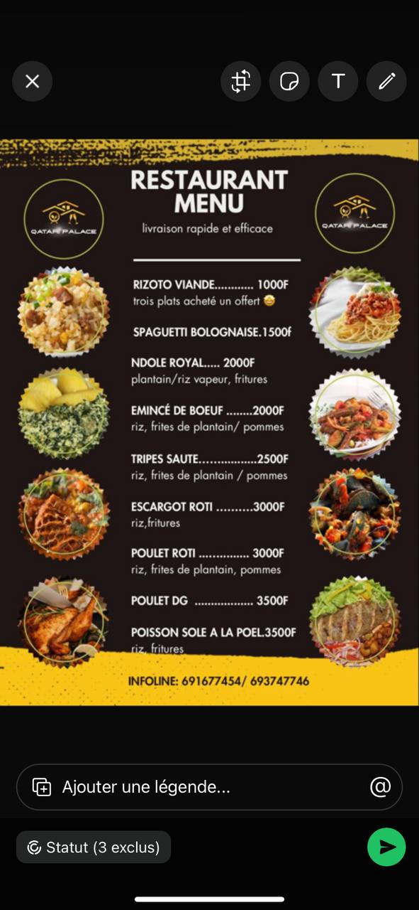

RESTAURANT MENU

Samsung galaxy…………………………………………………………25000 FCFA
Banche/bleu/noir
ROLEX………………………………………..………………………….….15000FCFA
NOIR/BLEU/ROUGE

MONTRES MECANIQUE……………………………………….………20000 FCFA
Banche/bleu/noir
RELOJ TISSOT…………………………………………………………….….15000FCFA
NOIR/BLEU/ROUGE

MONTRES MECANIQUE……………………………..…………..…….35000 FCFA
Banche/bleu/noir
MONTRE BRACELET………………………………………………………..15000FCFA
NOIR/BLEU/ROUGE

MONTRES CONNECTER……………..…………………………………....35000 FCFA
BLEU/ROUGE/NOIR
MONTRES CONNECTER……………………………………………………..65000 FCFA
BLEU/ROUGE/NOIR

LOCALISATION :BONABERIE(BESSECKE PETIT PONT)
CONTACT :693509213/658973212

